
PSYC602
S
OCIAL
P
SYCHOLOGY
W
EEK
2 (2020)
N
ORTH
AND
S
OUTH
Social Cognition
SOCIAL COGNITION is:
- an understanding of how we process social information,
form impressions of, and think about, ourselves and others
- how people think about themselves and the social world
- how people select, interpret, remember, and use social information to make judgements and decisions
- the cognitive (thinking) processes that influence, and
are influenced by, social context
SOCIAL COGNITION involves:
- mental processes that are largely automatic and run in the background like a computer processor. Our brains are continuously:
- Gathering information n Selecting information for decision-making n Integrating information into a judgement
- thinking that is most often conscious

Automatic thinking
- We use automatic thinking because it is easy, requires limited effort and is efficient
- And because it is believed that people have a limited capacity
to process information, making us ‘cognitive misers’ who take mental shortcuts
- Automatic thinking involves little effort because it relies
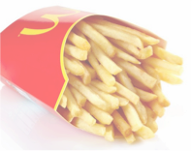
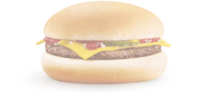
on knowledge structures
Over time, as related concepts are
frequently paired together, the
concepts
become
strongly linked
- organised sets of information stored in memory
- formed when a set of related
concepts is frequently brought to mind or activated
THE PROCESS OF …is ubiquitous to all social interactions, and
IMPRESSION FORMATION _{is influenced by:}
- Physical appearance
- A persons appearance is often the first information we have
about a person, and appearance-based impressions are surprisingly accurate, but sometimes biased, as when …
- People seen as good looking are also seen as more social,
friendly, competent and intelligent
- Stereotypes
- An organised and widely held set of beliefs about the
characteristics of a group of people

FORMING IMPRESSIONS (cont.)
- Order of information
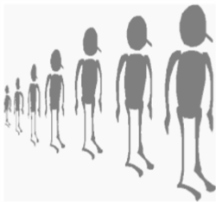
- The order of both positive and negative information about
a person can have a profound effect on our perception of them
- Personal constructs
- People tend to develop their own ways of characterising people. They tend to create general principles about what sorts of characteristics go together to form certain types of personalities

FORMING IMPRESSIONS (cont.)
- Salience

- People tend to direct attention to those aspects of
the perceptual field that stand out [figure-ground principle]
- When forming impressions, the most salient
aspects of the person will be most heavily used
- Traits
- Referring to traits is a more economical way to describe a
person (v. recalling each behaviour associated with them), such as warmor blunt
BIASES in forming impressions
- Primacy Effect
- Tendency to let first impressions influence our evaluations of
people
- Recency Effect
- When later information, with more impact than earlier
information, has a disproportionate influence on ones impression of a person n Between the two, Primacy remains the most powerful bias

MORE BIASES
- Halo Effect
- Tendency to evaluate consistent characterisations of
people, even when only a few pieces of information are available
- If a person is likeable, they are also seen as attractive, intelligent, generous, etc. n If they are perceived as bad, they are also sneaky, ugly, and inept n Confirmation Bias
- Tendency to seek ways to confirm rather than refute
existing beliefs
- https://www.youtube.com/watch?v=vKA4w2O61Xo

MORE BIASES
- Negativity Effect
- A negative trait affects an impression more than a positive
one, especially in the case of moral traits

- Therefore, if a person is initially seen to engage in
dishonest behaviour, they will be perceived more negatively
- Person-Positivity bias
- Tendency for people to evaluate individuals more
positively than they evaluate the groups that the person belongs to

SOCIAL SCHEMAS (_{plural)} or SCHEMATA (singular)
are a set of inter-related allow us to fill in the gaps

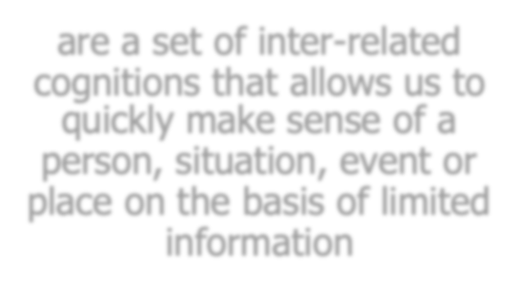



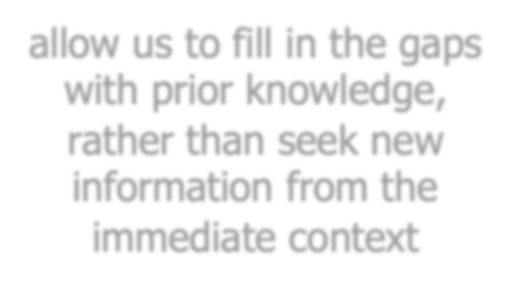


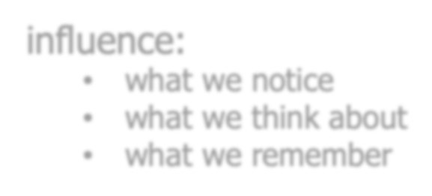

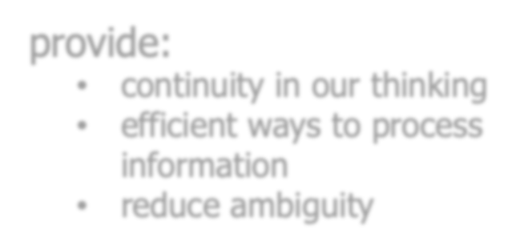

cognitions that allows us to with prior knowledge, quickly make sense of a rather than seek new
person, situation, event or information from the
place on the basis of limited immediate context
information
provide:
influence: • continuity in our thinking
- what we notice • efficient ways to process
- what we think about information
- what we remember • reduce ambiguity

SOCIAL SCHEMAS
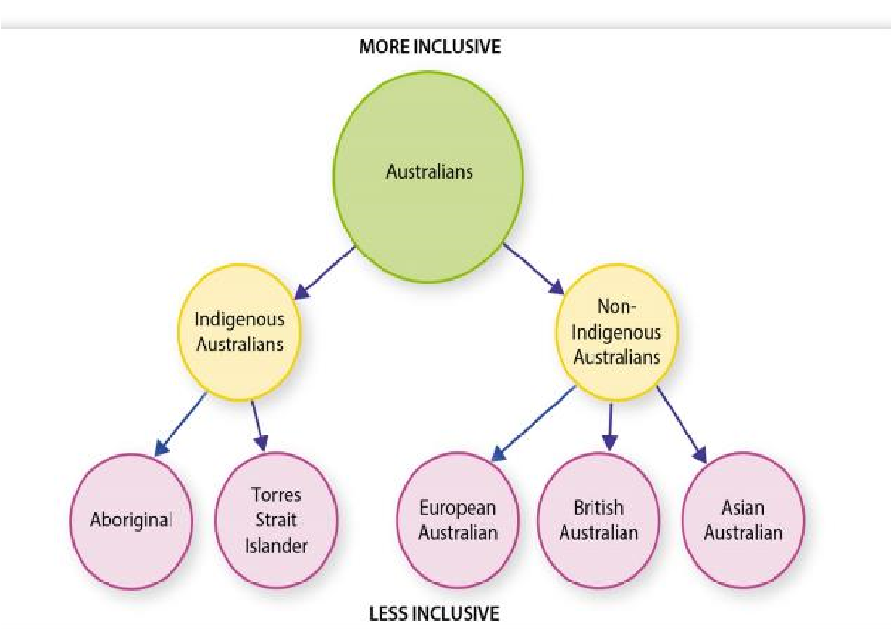
TYPES OF SCHEMAS






- Person schema
- Knowledge structures about specific people n Role schema
- Knowledge structures about role occupants
- ROLES: Patterns of behaviour that distinguish
between different activities within a group, and that interrelate to one another for the greater good
of the group
TYPES OF SCHEMAS (cont.)

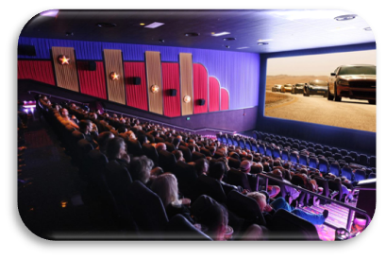
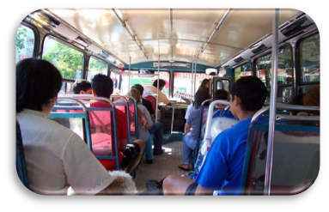
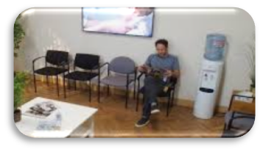
- Scripts
- Schemas about events, such as what to expect when we go to the movies, ride in an elevator, visit the doctor, etc.

n Self-schemas
n Information we hold about ourselves, which forms part of our selfconcept of who we are

SCHEMA USE
- In processing information ^{n subtypes}
about other people, we nn stereotypescurrent moods
tend to rely on schemas _{n} easily detected features relating to: n accessible categories
- self-relevant information
- However, people are less dependent on schemas
when:
- the cost of making a wrong inference is increased n the cost of being indecisive is low n people are aware that schematic processing may be inaccurate

SCHEMA DEVELOPMENT

Where do schemas come from?
- Real life experience (they get richer and more complex as we have more experiences)
- Media
- Stories our parents and friends tell us n Culture and socialisation
- Over time, schemas become more abstract, complex, and resilient
- They are hard to change, but can be modified by schema-inconsistent information, mainly through the formation of subtypes

The downside of schema use/categorisation
- Unintentional n Involuntary n Effortless  - These cognitive processes make the formation of impressions more efficient. | n However, the over-reliance on schemas and categorisation can lead to wrong inferences and the  stereotypingof people based on a small amount of information.

- Most of the time, social
cognition is automatic n Non-conscious
Which causes more deaths?




Being attacked by a shark? or Being struck by lightning?

HEURISTICS
- We take mental shortcuts (called heuristics). These provide adequatelyaccurate inferences (interpretations) most of the time. n These include:
- Representativeness heuristic: Instances are assigned to
categories based on the resemblance with that category
- Availability heuristic: how easily the examples of associations
come to mind (many news articles on sharks, but not lightning).

Next week …
n Attribution and _{n} Social identity and
social explanation the self
